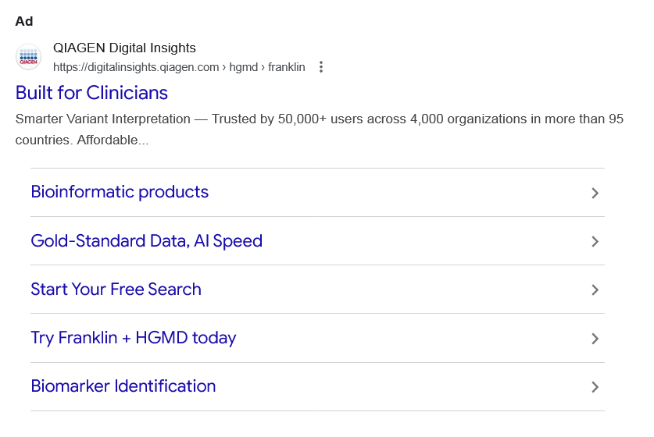
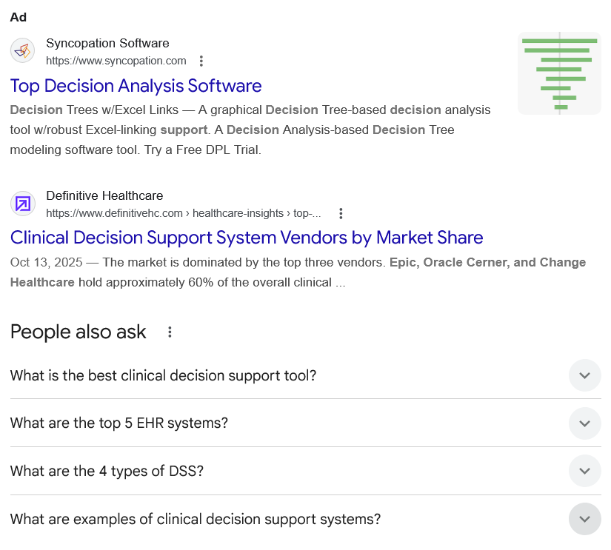
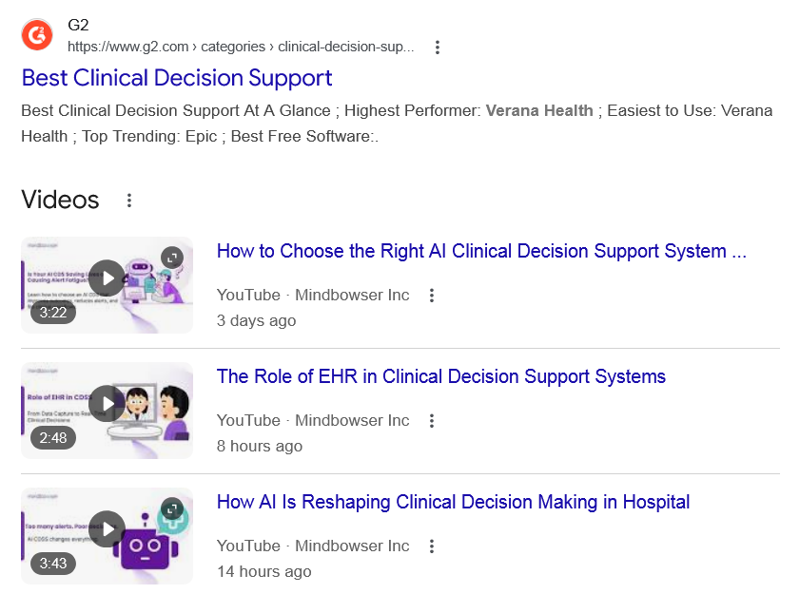
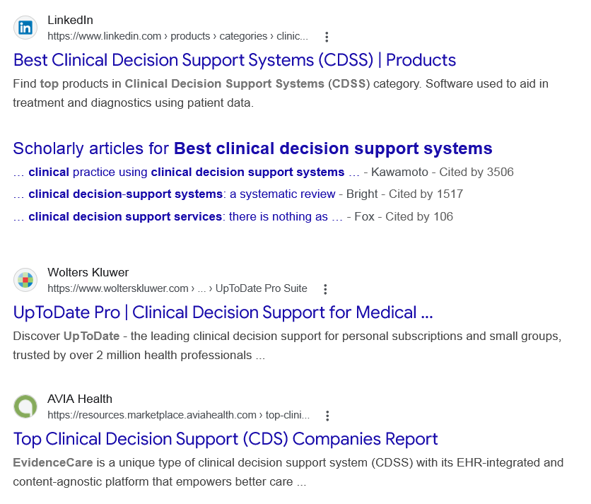
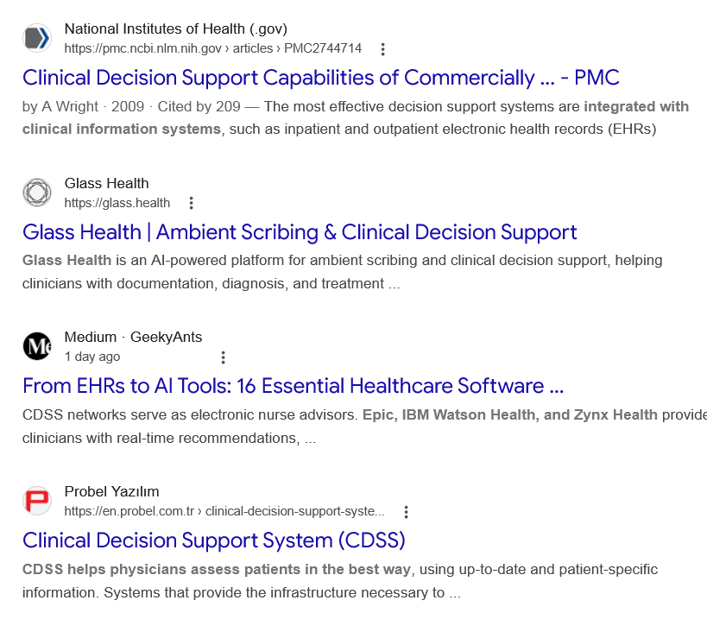
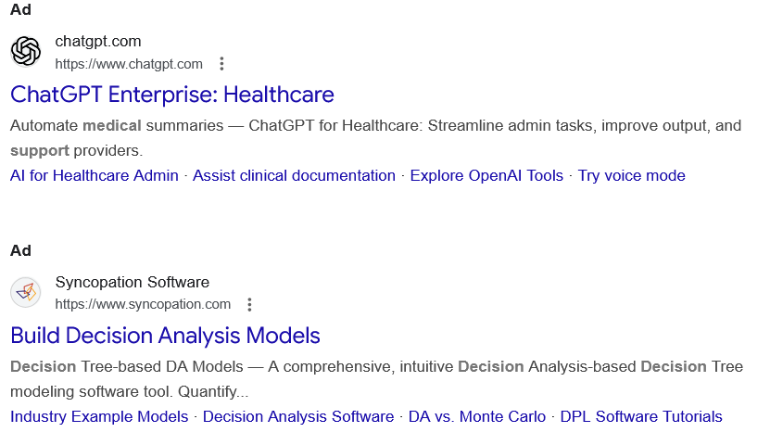
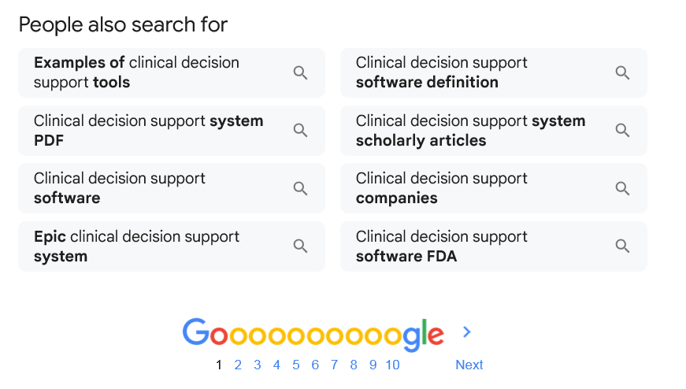
Ad

Built for Clinicians
QIAGEN Digital Insights
https://digitalinsights.qiagen.com › hgmd › franklin

QIAGEN Digital Insights
https://digitalinsights.qiagen.com › hgmd › franklin

My Ad Centre
Smarter Variant Interpretation — Trusted by 50,000+ users across 4,000 organizations in more than 95 countries. Affordable...

Bioinformatic products

Gold-Standard Data, AI Speed

Start Your Free Search

Try Franklin + HGMD today

Biomarker Identification

People also search for


Ad

Top Decision Analysis Software
Syncopation Software
https://www.syncopation.com

Syncopation Software
https://www.syncopation.com

My Ad Centre
Decision Trees w/Excel Links — A graphical Decision Tree-based decision analysis tool w/robust Excel-linking support. A Decision Analysis-based Decision Tree modeling software tool. Try a Free DPL Trial.

People also search for

Web results

Clinical Decision Support System Vendors by Market Share

Definitive Healthcare
https://www.definitivehc.com › healthcare-insights › top-...

Definitive Healthcare
https://www.definitivehc.com › healthcare-insights › top-...
Oct 13, 2025 — The market is dominated by the top three vendors. Epic, Oracle Cerner, and Change Healthcare hold approximately 60% of the overall clinical ...
People also ask
What is the best clinical decision support tool?
Ranked one of the best clinical decision support tools for health professionals worldwide*, BMJ Best Practice provides step-by-step guidance on diagnosis, treatment and prevention.

BMJ Best Practice: Homepage

The BMJ
https://bestpractice.bmj.com

The BMJ
https://bestpractice.bmj.com
What are the top 5 EHR systems?
Compare the best EHR systems: Specialties, features, pricing, practice size, & more
- Epic EHR. Epic Featured. ...
- MedEZ® Integrated Software Solutions. ...
- Tebra EHR. ...
- Nextech. ...
- Oracle Health EHR (formerly Cerner Ambulatory EHR) ...
- Ensora Mental Health (formerly TheraNest) ...
- Praxis EMR. ...
- CureMD All in One EHR.
More items...

EHR Software Comparison | 2026 Pricing, Features & More

EHR in Practice
https://www.ehrinpractice.com › ehr-product-comparison

EHR in Practice
https://www.ehrinpractice.com › ehr-product-comparison
What are the 4 types of DSS?
Various types of DSS exist, including model-driven systems, data-driven systems, knowledge-driven systems, and group support systems, each serving unique functions and addressing different facets of decision-making challenges.

Decision Support Systems | Business and Management | Research Starters

EBSCO
https://www.ebsco.com › research-starters › decision-sup...

EBSCO
https://www.ebsco.com › research-starters › decision-sup...
What are examples of clinical decision support systems?
Clinical decision support systems address activities ranging from the selection of medications (e.g., the optimal antibiotic choice given specific microbiologic data) or diagnostic tests (e.g., the best blood test to evaluate a patient with possible pulmonary embolism) to detailed support for optimal drug dosing and ...

Clinical Decision Support Systems | PSNet - AHRQ

Patient Safety Network - AHRQ
https://psnet.ahrq.gov › primer › clinical-decision-suppor...

Patient Safety Network - AHRQ
https://psnet.ahrq.gov › primer › clinical-decision-suppor...

Web results

Best Clinical Decision Support

G2
https://www.g2.com › categories › clinical-decision-sup...

G2
https://www.g2.com › categories › clinical-decision-sup...
Best Clinical Decision Support At A Glance ; Highest Performer: Verana Health ; Easiest to Use: Verana Health ; Top Trending: Epic ; Best Free Software:.
Videos

How to Choose the Right AI Clinical Decision Support System ...
YouTube · Mindbowser Inc
3 days ago

YouTube · Mindbowser Inc

3:22

The Role of EHR in Clinical Decision Support Systems
YouTube · Mindbowser Inc
8 hours ago

YouTube · Mindbowser Inc

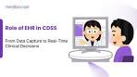
2:48

How AI Is Reshaping Clinical Decision Making in Hospital
YouTube · Mindbowser Inc
14 hours ago

YouTube · Mindbowser Inc

3:43

View all

Web results

Best Clinical Decision Support Systems (CDSS) | Products

LinkedIn
https://www.linkedin.com › products › categories › clinic...

LinkedIn
https://www.linkedin.com › products › categories › clinic...
Find top products in Clinical Decision Support Systems (CDSS) category. Software used to aid in treatment and diagnostics using patient data.

Scholarly articles for Best clinical decision support systems
… clinical practice using clinical decision support systems … - ‎Kawamoto - Cited by 3506
… clinical decision-support systems: a systematic review - ‎Bright - Cited by 1517
… clinical decision support services: there is nothing as … - ‎Fox - Cited by 106

Web results

UpToDate Pro | Clinical Decision Support for Medical ...

Wolters Kluwer
https://www.wolterskluwer.com › ... › UpToDate Pro Suite

Wolters Kluwer
https://www.wolterskluwer.com › ... › UpToDate Pro Suite
Discover UpToDate - the leading clinical decision support for personal subscriptions and small groups, trusted by over 2 million health professionals ...

Top Clinical Decision Support (CDS) Companies Report

AVIA Health
https://resources.marketplace.aviahealth.com › top-clini...

AVIA Health
https://resources.marketplace.aviahealth.com › top-clini...
EvidenceCare is a unique type of clinical decision support system (CDSS) with its EHR-integrated and content-agnostic platform that empowers better care ...

Clinical Decision Support Capabilities of Commercially ... - PMC

National Institutes of Health (.gov)
https://pmc.ncbi.nlm.nih.gov › articles › PMC2744714

National Institutes of Health (.gov)
https://pmc.ncbi.nlm.nih.gov › articles › PMC2744714
by A Wright · 2009 · Cited by 209 — The most effective decision support systems are integrated with clinical information systems, such as inpatient and outpatient electronic health records (EHRs)

Glass Health | Ambient Scribing & Clinical Decision Support

Glass Health
https://glass.health

Glass Health
https://glass.health
Glass Health is an AI-powered platform for ambient scribing and clinical decision support, helping clinicians with documentation, diagnosis, and treatment ...

From EHRs to AI Tools: 16 Essential Healthcare Software ...

Medium · GeekyAnts
1 day ago

Medium · GeekyAnts
1 day ago
CDSS networks serve as electronic nurse advisors. Epic, IBM Watson Health, and Zynx Health provide clinicians with real-time recommendations, ...

Clinical Decision Support System (CDSS)

Probel Yazılım
https://en.probel.com.tr › clinical-decision-support-syste...

Probel Yazılım
https://en.probel.com.tr › clinical-decision-support-syste...
CDSS helps physicians assess patients in the best way, using up-to-date and patient-specific information. Systems that provide the infrastructure necessary to ...
Ad

ChatGPT Enterprise: Healthcare

chatgpt.com
https://www.chatgpt.com

chatgpt.com
https://www.chatgpt.com

My Ad Centre
Automate medical summaries — ChatGPT for Healthcare: Streamline admin tasks, improve output, and support providers.
‎AI for Healthcare Admin · ‎Assist clinical documentation · ‎Explore OpenAI Tools · ‎Try voice mode
Ad

Build Decision Analysis Models
Syncopation Software
https://www.syncopation.com

Syncopation Software
https://www.syncopation.com

My Ad Centre
Decision Tree-based DA Models — A comprehensive, intuitive Decision Analysis-based Decision Tree modeling software tool. Quantify...
‎Industry Example Models · ‎Decision Analysis Software · ‎DA vs. Monte Carlo · ‎DPL Software Tutorials
People also search for

Examples of clinical decision support tools

Clinical decision support system PDF

Clinical decision support software

Epic clinical decision support system

Clinical decision support software definition

Clinical decision support system scholarly articles

Clinical decision support companies

Clinical decision support software FDA

Page navigation
 | 1 | 2 | 3 | 4 | 5 | 6 | 7 | 8 | 9 | 10 | Next

